初始输入时：



输入：x

N = 2 * batch_size, 一帧里面有两个人；

C = 3， channel = 3;

T = 150, #time_frame = 150;

V = 25, #vertex = 25;

M = 60, #action_class = 60;

x.size = (2, 3, 150, 25, 60)

维度变换和bn：



x.size = (2, 60, 25, 3, 150) 合并成 (2, 4500, 150)

data_bn = nn.BatchNorm1d (N * C * V) 即data_bn = nn.BatchNorm1d (150) 沿着第2维的方向做bn

再次展开：x.size = (2, 60, 25, 3, 150) -> x.size() = (2, 60, 3, 150, 25) -> x.size = (120, 3, 150, 25)

GCN结构：

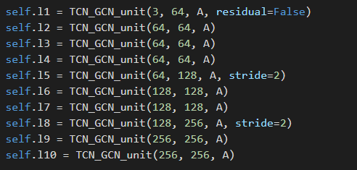

L1层运算：

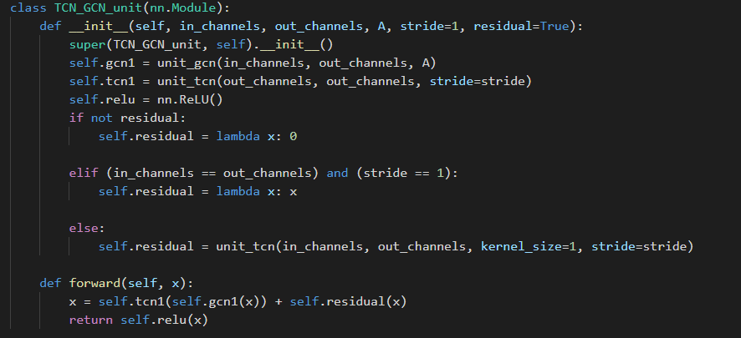

无残差模块，stride = 1, in_channel = 3, out_channel = 64

L1.gcn: in_channel = 3, out_channel = 64,

input_x.size = (120, 3, 150, 25)

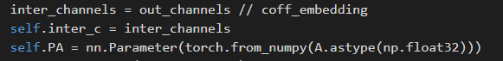

Inter_c = 64 // 4 = 16

PA = B, 对应原论文中f_out = w * f_in * (A + B + C), A为原始邻接矩阵

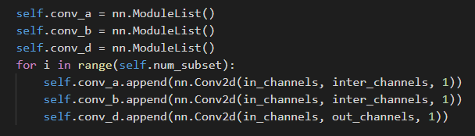

Conv_a: conv2d(in_c = 3, out_c = 16, kernel = 1, stride = 1), 连续三次

Conv_b: conv2d(in_c = 3, out_c = 16, kernel = 1, stride = 1), 连续三次

Conv_d: conv2d(in_c = 3, out_c = 64, kernel = 1, stride = 1), 连续三次

Conv_a的卷积参数size：(1, 3, 1, 1) * 16 filter * 3 loops

Conv_b的卷积参数size：(1, 3, 1, 1) * 16 filter * 3 loops

Conv_c的卷积参数size：(1, 3, 1, 1) * 64 filter * 3 loops

Gcn_forward:

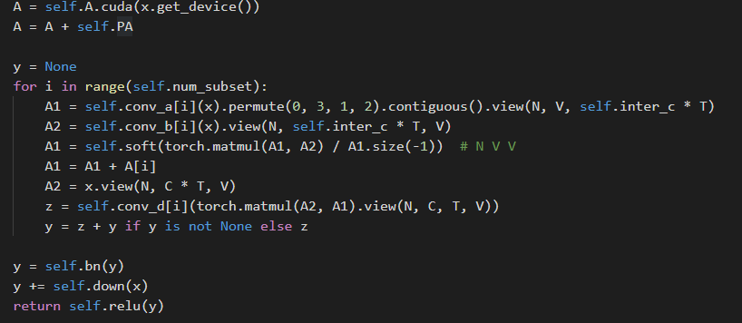

A = A + self.PA: 执行A+ B

Conv_a[0](x).size = (120, 16, 150, 25) -> (120, 25, 16, 150) -> 60 x (2, 25, 2400) ???

卷积核尺寸：(1, 3, 1, 1), 16个filter, 120*25*150*16 = 7.2M次向量乘加, 21.6M乘&14.4M加, 向量尺寸1x3

Conv_b[0](x).size = (120, 16, 150, 25) -> (120, 25, 16, 150) -> 60 x (2, 2400, 25) ???

卷积核尺寸：(1, 3, 1, 1), 16个filter, 120*25*150*16 = 7.2M次向量乘加, 21.6M乘& 14.4M加, 向量尺寸1x3

Matmul(A1, A2): 4次 (25, 2400) * (2400, 25) 的矩阵乘法，2500次向量乘加，6M乘&6M加，向量尺寸1x2400，输出尺寸(4, 25, 25) ???

A1 = Softmax(Matmul(A1, A2)): 得到C矩阵

A1 = A1 +A[i]: 执行A + B + C的操作

A2.size() = 60 x (2, 450, 25) ???

2020.10.26 1935 补充

Model中由10个TCN_GCN_unit模块组成，对应网络中的10层（block）

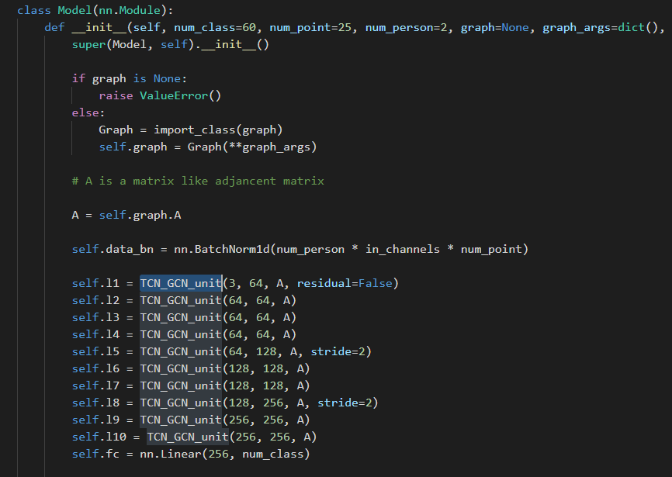

TCN_GCN_unit模块：

先做gcn1()

再做tcn1()

融合残差+residual()

最后relu()

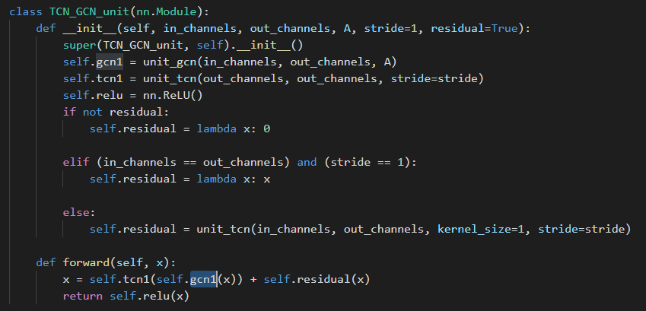

Unit_gcn()模块：

PA和A的size是一样，不过PA的值全被初始化为e-6.

class unit_gcn(nn.Module):

    def __init__(self, in_channels, out_channels, A, coff_embedding=4, num_subset=3):

        super(unit_gcn, self).__init__()

        inter_channels = out_channels // coff_embedding

        self.inter_c = inter_channels

        self.PA = nn.Parameter(torch.from_numpy(A.astype(np.float32)))

        nn.init.constant(self.PA, 1e-6)

        self.A = Variable(torch.from_numpy(A.astype(np.float32)), requires_grad=False)

        self.num_subset = num_subset

        self.conv_a = nn.ModuleList()

        self.conv_b = nn.ModuleList()

        self.conv_d = nn.ModuleList()

        for i in range(self.num_subset):

            self.conv_a.append(nn.Conv2d(in_channels, inter_channels, 1))

            self.conv_b.append(nn.Conv2d(in_channels, inter_channels, 1))

            self.conv_d.append(nn.Conv2d(in_channels, out_channels, 1))

        if in_channels != out_channels:

            self.down = nn.Sequential(

                nn.Conv2d(in_channels, out_channels, 1),

                nn.BatchNorm2d(out_channels)

            )

        else:

            self.down = lambda x: x

        self.bn = nn.BatchNorm2d(out_channels)

        self.soft = nn.Softmax(-2)

        self.relu = nn.ReLU()

        for m in self.modules():

            if isinstance(m, nn.Conv2d):

                conv_init(m)

            elif isinstance(m, nn.BatchNorm2d):

                bn_init(m, 1)

        bn_init(self.bn, 1e-6)

        for i in range(self.num_subset):

            conv_branch_init(self.conv_d[i], self.num_subset)

    def forward(self, x):

        N, C, T, V = x.size()

        A = self.A.cuda(x.get_device())

        A = A + self.PA

        y = None

        for i in range(self.num_subset):

            A1 = self.conv_a[i](x).permute(0, 3, 1, 2).contiguous().view(N, V, self.inter_c * T)

            A2 = self.conv_b[i](x).view(N, self.inter_c * T, V)

            A1 = self.soft(torch.matmul(A1, A2) / A1.size(-1))  # N V V

            A1 = A1 + A[i]

            A2 = x.view(N, C * T, V)

            z = self.conv_d[i](torch.matmul(A2, A1).view(N, C, T, V))

            y = z + y if y is not None else z

        y = self.bn(y)

        y += self.down(x)

        return self.relu(y)